SIMATS ENGINEERING
ASSESSMENT TOOL 1

COURSE NAME: Artificial Intelligence COURSE CODE: CSA1723

COURSE OUTCOME COVERED

CO1: Apply AI basics such as intelligent agents and uninformed search methods to
solve problems effectively. (BL3)
Assessment Tool Weightage: 35%

QUESTIONS: 5 Duration: 1 Hour
Total Marks: 50
ANNEXURE A
ANALYTICAL PROBLEM SOLVING
Code of Conduct
I SHREE AISHWARYA.R(192521475) (Name / Reg No) certify that this submission is my original work and that I have adhered to the guidelines specified for this assessment. I understand that any violation of academic integrity rules will result in disciplinary action.
Shree Aishwarya .R
Signature of the student:

Question 1: Water Jug Problem
Objective: Obtain exactly 2 gallons of water in the 4-gallon jug using only a 4-gallon jug, a 3-gallon jug, and the permitted operations of filling, emptying, and pouring.

State representation
Represent each state as (x, y), where x is the amount of water in the 4-gallon jug and y is the amount in the 3-gallon jug. The initial state is (0, 0), and the goal condition is x = 2.

Solution steps
- Start with both jugs empty: (0, 0).
- Fill the 3-gallon jug: (0, 3).
- Pour the 3-gallon jug into the 4-gallon jug: (3, 0).
- Fill the 3-gallon jug again: (3, 3).
- Pour from the 3-gallon jug into the 4-gallon jug until the 4-gallon jug is full. Only 1 gallon fits, leaving 2 gallons in the 3-gallon jug: (4, 2).
- Empty the 4-gallon jug onto the ground: (0, 2).
- Pour the remaining 2 gallons from the 3-gallon jug into the 4-gallon jug: (2, 0).
Result: The 4-gallon jug contains exactly 2 gallons. The method uses only the operations permitted in the question and requires no measuring instrument.
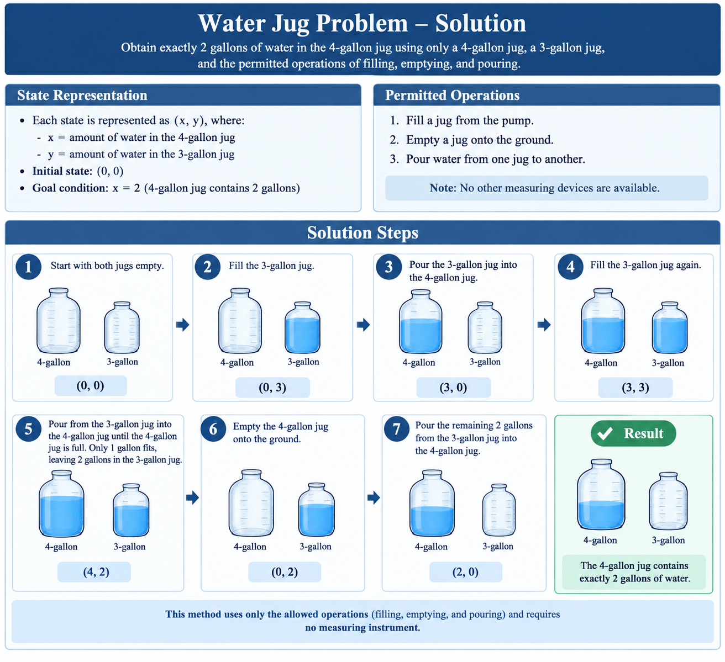

Question 2: Mars Rover as an Intelligent Agent
A Mars rover is an autonomous or semi-autonomous intelligent agent that senses its surroundings, interprets observations, selects actions, and performs scientific exploration while operating under communication delays and limited energy.

i. Percepts of the agent
The rover receives percepts from cameras and navigation sensors, wheel encoders, inertial sensors, proximity and hazard detectors, temperature and power sensors, and scientific instruments such as spectrometers and cameras used to inspect rock and soil. These percepts provide information about terrain, obstacles, position, slope, environmental conditions, battery state, and sample composition.

ii. Operating environment
The environment is partially observable because sensors cannot reveal every feature of the terrain or the complete composition of a sample. It is sequential because each movement affects later choices; dynamic because lighting, dust, and environmental conditions may change; and stochastic because wheel slippage and sensor noise make outcomes uncertain. It is also largely unknown, physically continuous, and resource-constrained by power, storage, and communication windows.

iii. Actions available to the agent
The rover can move forward or backward, turn, stop, avoid obstacles, select a route, capture images, measure environmental conditions, inspect rocks or soil, collect or drill a sample when equipped, store scientific data, transmit results, and enter a low-power or safe mode.

iv. Performance evaluation
Performance can be evaluated using scientific value of collected data, accuracy of sample analysis, distance safely explored, successful completion of mission objectives, navigation accuracy, avoidance of collisions and damage, energy efficiency, communication reliability, and the amount of usable data returned to Earth. A good performance measure balances scientific achievement with safety and resource use.

v. Most suitable agent architecture
A model-based, goal-based agent augmented with utility-based decision-making is most suitable. A model-based component maintains an internal map and estimates the rover’s state despite incomplete observations. Goal-based planning chooses actions that advance objectives such as reaching a rock formation or collecting a sample. Utility-based evaluation compares alternatives by scientific benefit, risk, time, and energy. A reflex safety layer can immediately stop or avoid hazards. This hybrid architecture supports planning under uncertainty while respecting real-time safety constraints.

Question 3: Formulating and Exploring the 8-Queens Problem
The objective is to place eight queens on an 8 × 8 chessboard so that no two queens share a row, column, or diagonal.

Problem formulation
Initial state: An empty chessboard, with no queens placed.
State representation: A partial assignment of queen positions by column. A state can be represented as a list in which the value at index c gives the row of the queen in column c.
Actions: Place a queen in the next column in any row that is not attacked by an already placed queen.
Transition model: Adding a legal queen position creates a new partial board.
Goal test: Eight queens have been placed and no pair attacks each other.
Path cost: A simple formulation assigns cost 1 to each queen placement; all complete solutions then have cost 8.

Search strategy
Depth-first search with backtracking is appropriate. It places one queen per column, explores a legal row, and moves to the next column. If no safe row exists, it removes the previous queen and tries another row. This avoids considering boards that already violate the constraints. Breadth-first search is possible but would retain many partial boards in memory; backtracking DFS is generally more memory-efficient for this problem.

Constraint test
For a queen at (r1, c1) and another at (r2, c2), the pair is safe when r1 ≠ r2 and |r1 − r2| ≠ |c1 − c2|. Since the representation places only one queen in each column, column conflicts are prevented by construction.

One valid solution
Using columns 1 through 8, one valid row assignment is [1, 5, 8, 6, 3, 7, 2, 4]. This means the queens occupy (1,1), (5,2), (8,3), (6,4), (3,5), (7,6), (2,7), and (4,8). No two of these positions share a row or diagonal.
Q
Q
Q
Q
Q
Q
Q
Q
The configuration shown is an example of a goal state. The figure mentioned in the supplied question is not visible in the provided PDF pages, so the solution above is presented independently.

Question 4: OLA Cab Booking as a Problem-Solving Agent
A goal-based problem-solving agent is suitable because the customer has a destination to reach and the agent must identify a feasible sequence of steps to achieve that goal. In practice, a utility-based layer can compare cab categories using fare, estimated travel time, comfort, availability, and the customer’s preferences. The selected cab must satisfy the customer’s constraints while providing a useful trade-off.

Problem definition
Initial state: The customer’s current location, destination, selected preferences, and current cab availability.
Goal state: A valid booking is confirmed and the customer is transported to the requested destination.
Actions: Enter destination, request fare estimates, select a cab category, confirm booking, track the driver, and complete the trip.
Constraints: Cab availability, fare budget, estimated arrival time, passenger capacity, and user-selected comfort preferences.
Performance measure: Successful arrival, reasonable cost and travel time, safety, and customer satisfaction.

Pseudocode
BEGIN
INPUT current_location, destination
INPUT preferred_cab_type, budget, comfort_preference
IF current_location is invalid OR destination is invalid THEN
DISPLAY "Please enter valid locations"
STOP
ENDIF
available_cabs <- GET_AVAILABLE_CABS(current_location)
IF available_cabs is empty THEN
DISPLAY "No cabs are currently available"
STOP
ENDIF
feasible_cabs <- empty list
FOR each cab IN available_cabs DO
fare <- ESTIMATE_FARE(cab, current_location, destination)
eta <- ESTIMATE_TRAVEL_TIME(cab, current_location, destination)
IF fare <= budget AND MATCHES_COMFORT(cab, comfort_preference) THEN
ADD (cab, fare, eta) TO feasible_cabs
ENDIF
ENDFOR
IF feasible_cabs is empty THEN
DISPLAY "No cab matches the selected constraints"
OFFER alternative cab types or budget
STOP
ENDIF
selected_cab <- CHOOSE_BEST(feasible_cabs,
preferred_cab_type,
fare,
eta,
comfort_preference)
SHOW selected_cab, estimated_fare, estimated_arrival_time
IF customer confirms THEN
booking <- CONFIRM_BOOKING(selected_cab)
DISPLAY booking_details
TRACK_CAB_UNTIL_ARRIVAL()
ELSE
DISPLAY "Booking cancelled"
ENDIF
END
The pseudocode separates feasibility checking from preference-based selection. This prevents the agent from choosing a cab that is unavailable or violates the customer’s stated constraints.

Question 5: Uniform Cost Search for the Logistics Network
Uniform Cost Search (UCS) finds a least-cost path by expanding the frontier node with the lowest cumulative path cost g(n). It is appropriate when route costs are non-negative and the objective is to minimize the sum of travel costs from starting warehouse S to destination warehouse G.

Algorithm
UNIFORM-COST-SEARCH(start S, goal G):
frontier <- priority queue ordered by cumulative cost
INSERT (cost = 0, node = S, path = [S]) INTO frontier
best_cost[S] <- 0
WHILE frontier is not empty DO
(cost, node, path) <- REMOVE entry with minimum cost
IF cost > best_cost[node] THEN
CONTINUE
ENDIF
IF node = G THEN
RETURN path, cost
ENDIF
FOR each neighbor v of node DO
new_cost <- cost + edge_cost(node, v)
IF v not in best_cost OR new_cost < best_cost[v] THEN
best_cost[v] <- new_cost
INSERT (new_cost, v, path followed by v) INTO frontier
ENDIF
ENDFOR
ENDWHILE
RETURN "No path exists"

How UCS determines the answer
- Initialize the cumulative cost at S to 0 and place S in the priority queue.
- Remove the node with the smallest known cumulative cost.
- For each outgoing route, add the route cost to the current cumulative cost.
- Update a neighbor only when the newly found path is cheaper than its previously recorded cost.
- Stop when G is removed from the priority queue; under non-negative edge costs, this is the least-cost path.
Important limitation of the supplied assessment: the question states that the network is represented by a weighted graph, but the graph and its edge weights are not visible in the provided four-page PDF. Therefore, the exact least-cost route and its numerical total cannot be calculated reliably from the supplied material. Insert the graph or provide the edge list to complete the final cost comparison without inventing route data.

Conclusion
These solutions apply state-space search, intelligent-agent design, constraint-based search, goal-oriented planning, and cost-based graph search to the five assessment problems. Each method is selected to match the structure of the task: state transitions for the water jugs, perception and decision-making for the rover, backtracking for 8-Queens, preference-aware planning for cab booking, and cumulative-cost optimization for UCS.

RUBRICS
The following rubric is transcribed from the supplied assessment PDF and formatted as an editable Word table.
Criteria | Weightage | Level 4 (Exemplary) | Level 3 (Proficient) | Level 2 (Developing) | Level 1 (Beginning)
Problem Understanding | 20% | Clearly interprets the problem, identifies all parameters and requirements accurately. | Understands the problem with minor gaps. | Partial understanding; misses key elements. | Misinterprets or is unable to understand the problem.
Method Selection | 20% | Selects the most appropriate method/formula with strong justification. | Selects the correct method with minor errors. | Inappropriate or partially correct method. | Unable to select a method.
Solution Process | 25% | Logical, systematic steps with the correct approach throughout. | Mostly correct steps with minor mistakes. | Disorganized steps; multiple errors. | No clear process.
Accuracy of Calculation | 20% | All calculations accurate; correct final answer. | Minor calculation errors. | Frequent errors; incorrect final answer. | No valid calculations.
Interpretation of Results | 15% | Clearly interprets results with units and engineering relevance. | Basic interpretation with minor omissions. | Limited or unclear interpretation. | No interpretation.

